

What Is Red Light Therapy
When you expose your entire body to red and near-infrared light, a part of your cells called the mitochondria, or the “powerhouse” of your cells, soak it up and make more energy, also known as ATP (adenosine triphosphate). By increasing the function of the mitochondria using Red Light Wellness, a cell can make more ATP. With more energy, cells can function more efficiently, rejuvenate themselves, and repair damage.
Red and near-infrared light occupy the “long end” of the visible spectrum with wavelengths of 630nm-940nm. Red and near-infrared light is effective for use on the skin's surface and can penetrate up to two inches into the body affecting the cells, tissues, blood, nerves, the brain, and bone.
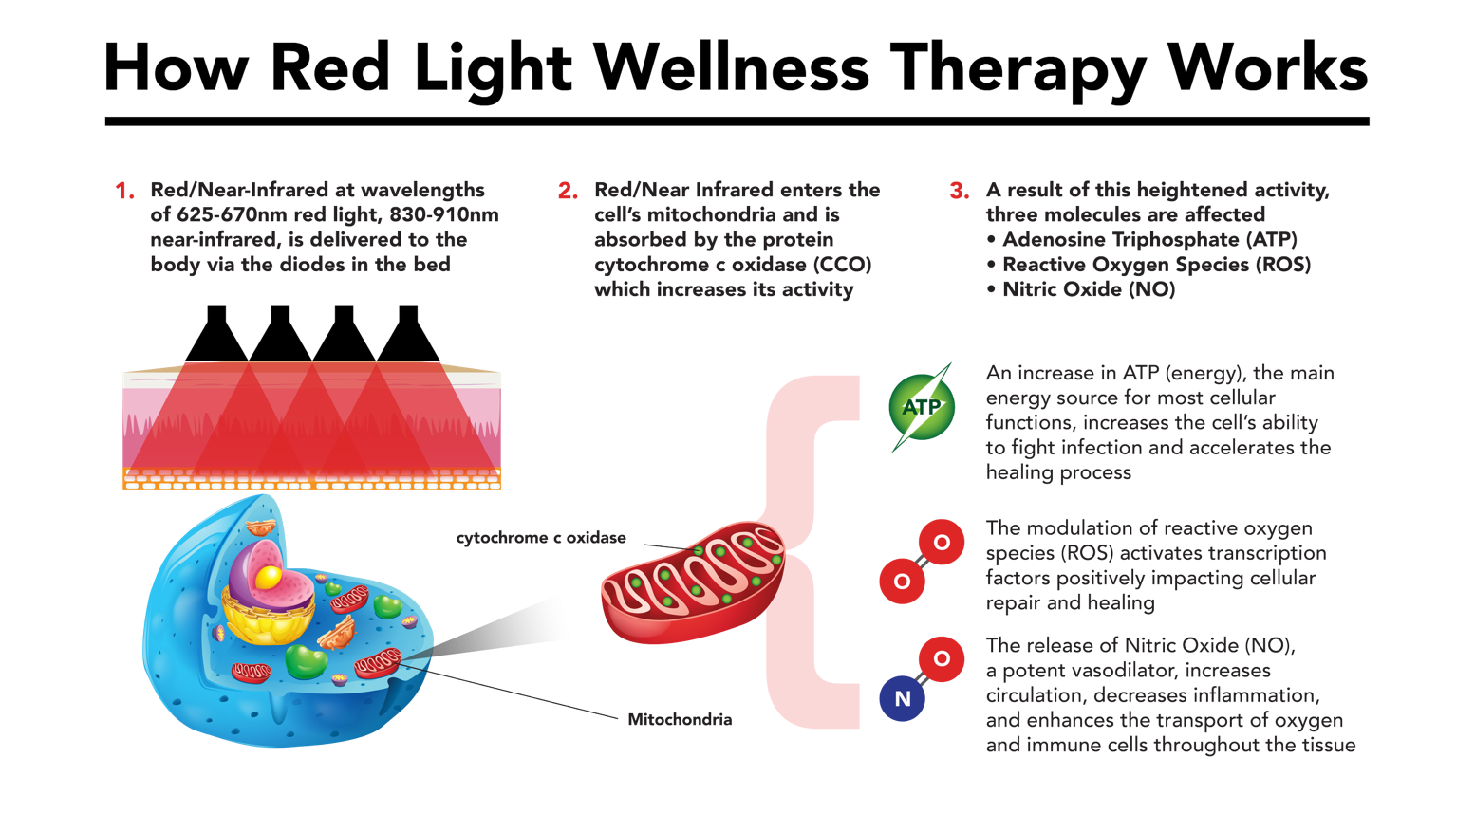

Is Red Light Therapy Safe?
Red light therapy is generally considered safe, especially when protective measures are taken for the eyes, as prolonged exposure to high-intensity red or NIR light can cause eye strain or potential damage. Following device instructions regarding exposure time and distance can help minimize any risks.
Contraindications
People with photosensitivity disorders or those taking photosensitizing medications should consult a healthcare provider before starting red light therapy, as it may aggravate sensitivity issues.

What Other Medical Conditions is Red Light Therapy Being Promoted For?
Beyond skin health, red light therapy is also being explored for various other conditions:
- Muscle Recovery and Joint Pain: RLT can aid muscle recovery and reduce soreness, making it popular among athletes.
- Mental Health: Some users report relief from symptoms of depression and anxiety, though more research is needed to substantiate these claims.
- Arthritis and Chronic Pain: Red light’s anti-inflammatory effects have shown promise for people dealing with chronic pain, including arthritis sufferers.
- And More Ask our office about it today

